DBMS Assingment

Tathagat Banerjee

17BCE7100

1.

/\*SELECT \* FROM database1.book where bid not in (select distinct bid from database1.grading);\*/

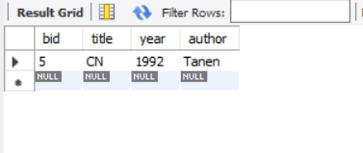

2.

/\*SELECT title FROM database1.book where bid not in(

select b.bid from database1.book as b join database1.grading as g join database1.editor as e

where b.bid = g.bid

and g.eid = e.eid

and e.ename='Smith')\*/

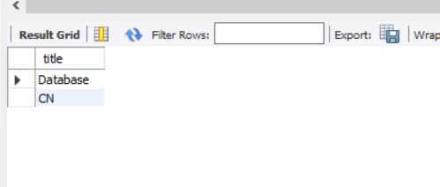

3.

/\*

select title, max(g.grade) from database1.grading as g join database1.book as b

where g.bid = b.bid

group by g.bid \*/

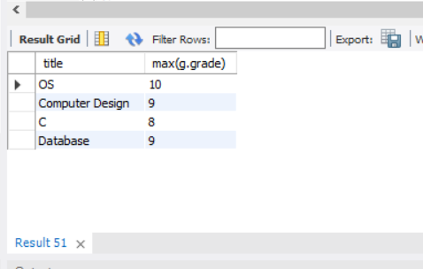

4.

/\*

select title, max(g.grade)-min(g.grade) as Difference from database1.grading as g join database1.book as b

where g.bid = b.bid

group by g.bid\*/

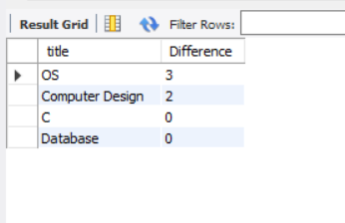

5.

/\*

select e.ename from database1.book as b join database1.grading as g join database1.editor as e

where b.bid = g.bid

and g.eid = e.eid

and b.title = 'OS'\*/

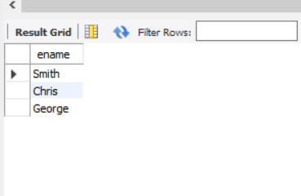

6.

/\*

select \* from database1.book as b join database1.grading as g join database1.editor as e

where b.bid = g.bid

and g.eid = e.eid

and b.author = e.ename\*/

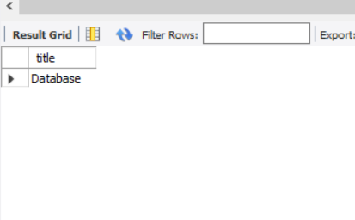

7.

/\*

select e.ename from database1.grading as g join database1.editor as e

where e.eid = g.eid

group by g.eid

having count(\*) > 1\*/

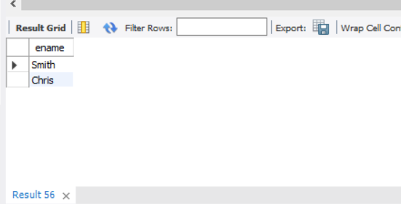

8.

/\*

select title , year , author from database1.book where year = (select min(year) from database1.book where year > (select min(year) from database1.book where year > (select min(year) from database1.book )) )

\*/

